**Assignment No:2**

**TITLE:**

SET THEORY.

**PROBLEM STATEMENT:**

In Second year Computer Engineering class of M students, set A of students play cricket and set B of students play badminton. Write C/C++ program to find and display-

i. Set of students who play either cricket or badminton or both.

ii. Set of students who play both cricket and badminton.

iii. Set of students who play only cricket.

iv. Set of students who play only badminton.

v. Number of students who play neither cricket nor badminton.

**PRE REQISITE:**

1. Concept of array.

2. Set Theory.

3. Basic C++ concepts and syntax.

**Learning Objective:**

1. To study use of array.

2. To insert data into array and extract data from the array.

3. To design efficient algorithm to solve given problem statement.

**Outcome:**

1. Use of array in solving various programming concepts.

2. Use of algorithm and flowchart to give step by step solution to given problem statement.

**THEORY:**

**Set Theory:**

* In [mathematics](https://en.wikipedia.org/wiki/Mathematics), a **set** is a collection of distinct objects, considered as an [object](https://en.wikipedia.org/wiki/Mathematical_object) in its own right. For example, the numbers 2, 4, and 6 are distinct objects when considered separately, but when they are considered collectively they form a single set of size three, written {2,4,6}. Sets are one of the most fundamental concepts in mathematics.
* Set notation uses curly braces, with elements separated by commas.

Example:Q= {2, 4, 6, 8}

**Cardinality of finite Set :**

The number of elements in a set.”

Let A be a set.

a.If A = ∅ (the empty set), then the cardinality of A is 0.

b. If A has exactly n elements, n a natural number, then the cardinality of A is n. The set A is a finite set.

c. Otherwise, A is an infinite set.

The cardinality of a set A is denoted by | A |.

1. If A = ∅ , then | A |= 0.
2. If A has exactly n elements, then | A | = n.
3. If A is an infinite set, then | A | = ∞

**Union of Set:**

In set theory, the union (denoted by ∪) of a collection of setsis the set of all distinct elements in the collection. It is one of the fundamental operations through which sets can be combined and related to each other.

The union set operations can be visualized from the diagrammatic representation of sets.The rectangular region represents the universal set U and the circular regions the subsets A and B. The shaded portion represents the set name below the diagram.

Let A and B be the two sets. The union of A and B is the set of all those elements which belong either to A or to B or both A and B.

**Intersection of Sets:**

Let A and B be the two sets. The intersection of A and B is the set of all those elements which belong to both A and B.

Now we will use the notation A ∩ B (which is read as ‘A intersection B’) to denote the intersection of set A and set B.

**1.Array:**

An array is a series of elements of the same type placed in contiguous memory locations that can be individually referenced by adding an index to a unique identifier.  
That means that, for example, five values of type int can be declared as an array without having to declare 5 different variables (each with its own identifier). Instead, using an array, the five int values are stored in contiguous memory locations, and all five can be accessed using the same identifier, with the proper index.

**2.One dimensional /Linear array:**

A one-dimensional array (or single dimension array) is a type of linear array. Accessing its elements involves a single subscript which can either represent a row or column index.

As an example consider the C declaration int anArrayName[10];

Syntax : datatype anArrayname[sizeofArray];

**3. Traversing :**

Traversing an array means to iterate an array and access every data element in the array.

**ALGORITHM:**

Step 1:Start

Step 2:Accept total number of students in class SE.

Step 3.Accept roll number of student s in class ,also accept roll number of students who play cricket and badminton.

Step 4:Accept choice of operation to be performed.

Step 5:Perform operation depending on choice of user.

Step 6:Ask from the user whether they want to continue(y/n).

Step 7:If yes repeat step 4,5,6.

Step 8:Stop.

**VENN DIAGRAM** : This shows all the above cases diagrammatically.

* Easily traceable problems.
* Makes understanding of sets better.
* Helps us represent two different sets.

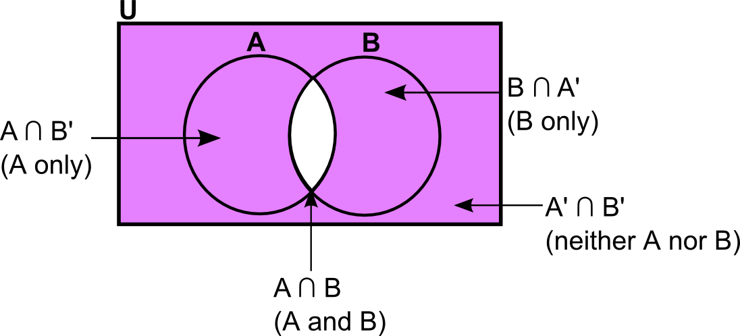

**FLOWCHART;**

